A NEW THEORY OF THE ORIGIN OF BIRD FLIGHT – SUMMARY
by Gary Schweitzer Tong (2009)
http://www.garystong/gstbio.pdf

1. THE FIRST CLUE
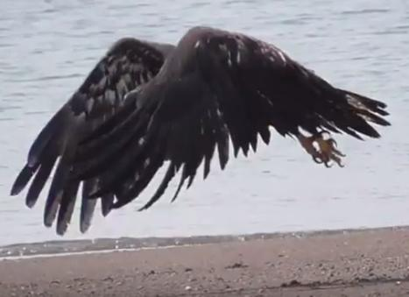
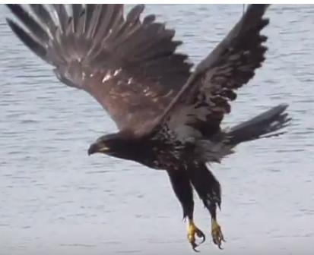
A coordinated rotation of hind and fore limbs in contrary directions is a universal behavior in terrestrial vertebrates. It appears in walking, running, jumping, etc. It can be called coordinated rotation of appendages, or CR.
A considerable repertory of photo and video data clearly shows that in their ground based takeoff behavior large birds, like eagles or herons simultaneously extend and flex the legs and wings in opposite directions, demonstrating that CR is present in birds. Examples:
https://www.youtube.com/watch?v=UFiYSHFh4qM
https://www.youtube.com/watch?v=W77Rt8PicBk
https://www.youtube.com/watch?v=GCb9-PKs8Gc
https://www.youtube.com/watch?v=0JBSmCbWLOQ
https://www.youtube.com/watch?v=9CDHYwj4QUM
https://mashable.com/video/slow-motion-birds-closeup/

2. THE PROBLEM
This coordinated limb rotation is what all previous ground-up cursorial-based theories of the source of avian flight have utilized in connecting it with running, jumping, and most recently with vertical plane running (WAIR), in all of which arm action assists leg motion. Nevertheless, none of these have offered a fully convincing, unbroken chronology of flight evolution.

3. THE SECOND CLUE AND THE SOLUTION
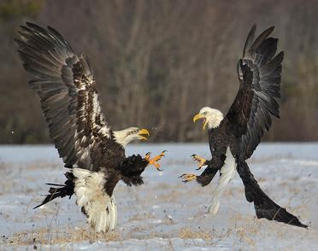
The reason for this problem lies in the insistent search for a secondary arm flap movement that would aid the primary leg movement in some cursorial locomotive behavior.
Leaving behind this parameter invites us to consider coordinated fore and hind leg actions which are not locomotive. There is one: striking with the hind-claw, a behavior ubiquitous in avian aggression and one of high fitness selective value.
The sizable and readily available video and photographic data clearly illustrates that striking with hind claws is in all instances accompanied by rapid and powerful wing flaps, whether in the air or on the ground. (We can confidently challenge anyone to show cases where this is not true). Asked to verify fact this three ornithologists contacted have sent confirmation. The simultaneous clawing movement and wing flapping is a manifestation of coordinated rotation (CR). Examples:
https://www.google.com/search?q=birds+fighting+images&client=firefox-b-1&tbm=isch&source=iu&ictx=1&fir=K4jLks_q79PBIM%253A%252Cvu2mpnxei9HuxM%252C_&usg=AI4_kTzYMyAH975i8gxJV2K1UgvvXrkHQ&sa=X&ved=2ahUKEwi81qmBtOzfAhUrnOAKHYerDW8Q9QEwAHoECAAQBA#imgrc=K4jLks_q79PBIM:

Cursorial dinosaurs possessed formidable hind claws which undoubtedly were their most potent weapons. As dictated by CR, leg movements in hind clawing would elicit powerful arm flaps, cf. human jump with simultaneous arm extensions.
Thus, given that small bipedal running carnivorous dinosaurs utilized hind-claw aggression, then lift, without running or jumping was potentially present in the protobird, and only awaited the appearance of feathered flight surfaces on the arms. A concise evolution and chronology of flight origins can thus be described. This theory is Uniformitarian: the element of clawing as the source of takeoff is apparent in current bird behavior.
Note: it is a fact that the architecture of the flight stroke is not unique to birds; it is already active in fish. E.g.,
1. WEBB, P. W. (1973). Kinematics of pectoral fin propulsion in Cymatogaster aggregata. J. exp. Biol. 59, 697–710.
link: http://jeb.biologists.org/content/jexbio/59/3/697.full.pdf
(p.5 " In this way thrust is generated throughout abduction andadduction phases in similar fashion to the generation of lift through most of the wing-beat cycle of many birds.”)
2. https://www.youtube.com/watch?v=CV0D6G4CTio&feature=youtu.be
3. http://foodweb.uhh.hawaii.edu/MARE%20594/Rosenberger%202001.pdf
p. 9 " The fins move up and down in a flapping motion analogous to flight in birds."

