Rev mu vs wu: techings to Japan came early pbb from Southern (Cantonese speakers)
who used the older form mou.
Even without ms use, verbal/cognitive use of Mu is very good.

Left-right sides only for holding mu or whatever.

1. When standing, walking or running, quadruped animals use their back muscles to support their bodies. Humans are upright, but still behave likewise, so during these actions, while the legs are moved by their own musculatures the body is constantly anchored by the dorsal muscles. For this reason, mindfulness is best kept by focusing on the back torso muscles because these are steadfast; the frontal and other body parts are in motion and cause thought to also move.

2. In walking it is diffucult to find a body part that can be concentrated on, chiefly because the action is complex. It helps to keep attention on a transverse, ie., horizontal section, be that in the chest, in the upper abdomen, or in the pelvis, and even even the feet. The option depends on body position, even on tilt of the head.

Crossing the legs also anchors the tongue, centered in the mouth, with slight bias to one side. This also stavbilizies the mind. Walking likewise braces the tongue.

The fingers in yogic position, thumb and index fingers as a circle and the other three spread out,is useful to keep mindful in any sitution outside meditation.

RSP diredtion and mind: this goes to HOVA?
Ramana maharshi has instructed that exhalation/rechaka or “Naham chinta” is “I am not the body”; inhalation/puraka or “Koham” is “who am I”; and retention of breath/kumbaka or “Soham” is “I am He”.
This may have been of less use for Western students who might not authentically produce the appropriate Sanskrit terms and for whom the following is the more correct scheme of respiration. Expiration moves the mind to perceive the outer world, holding the breath brings on attention and inspiration produces the sense of self.

Finger anchors of the mind
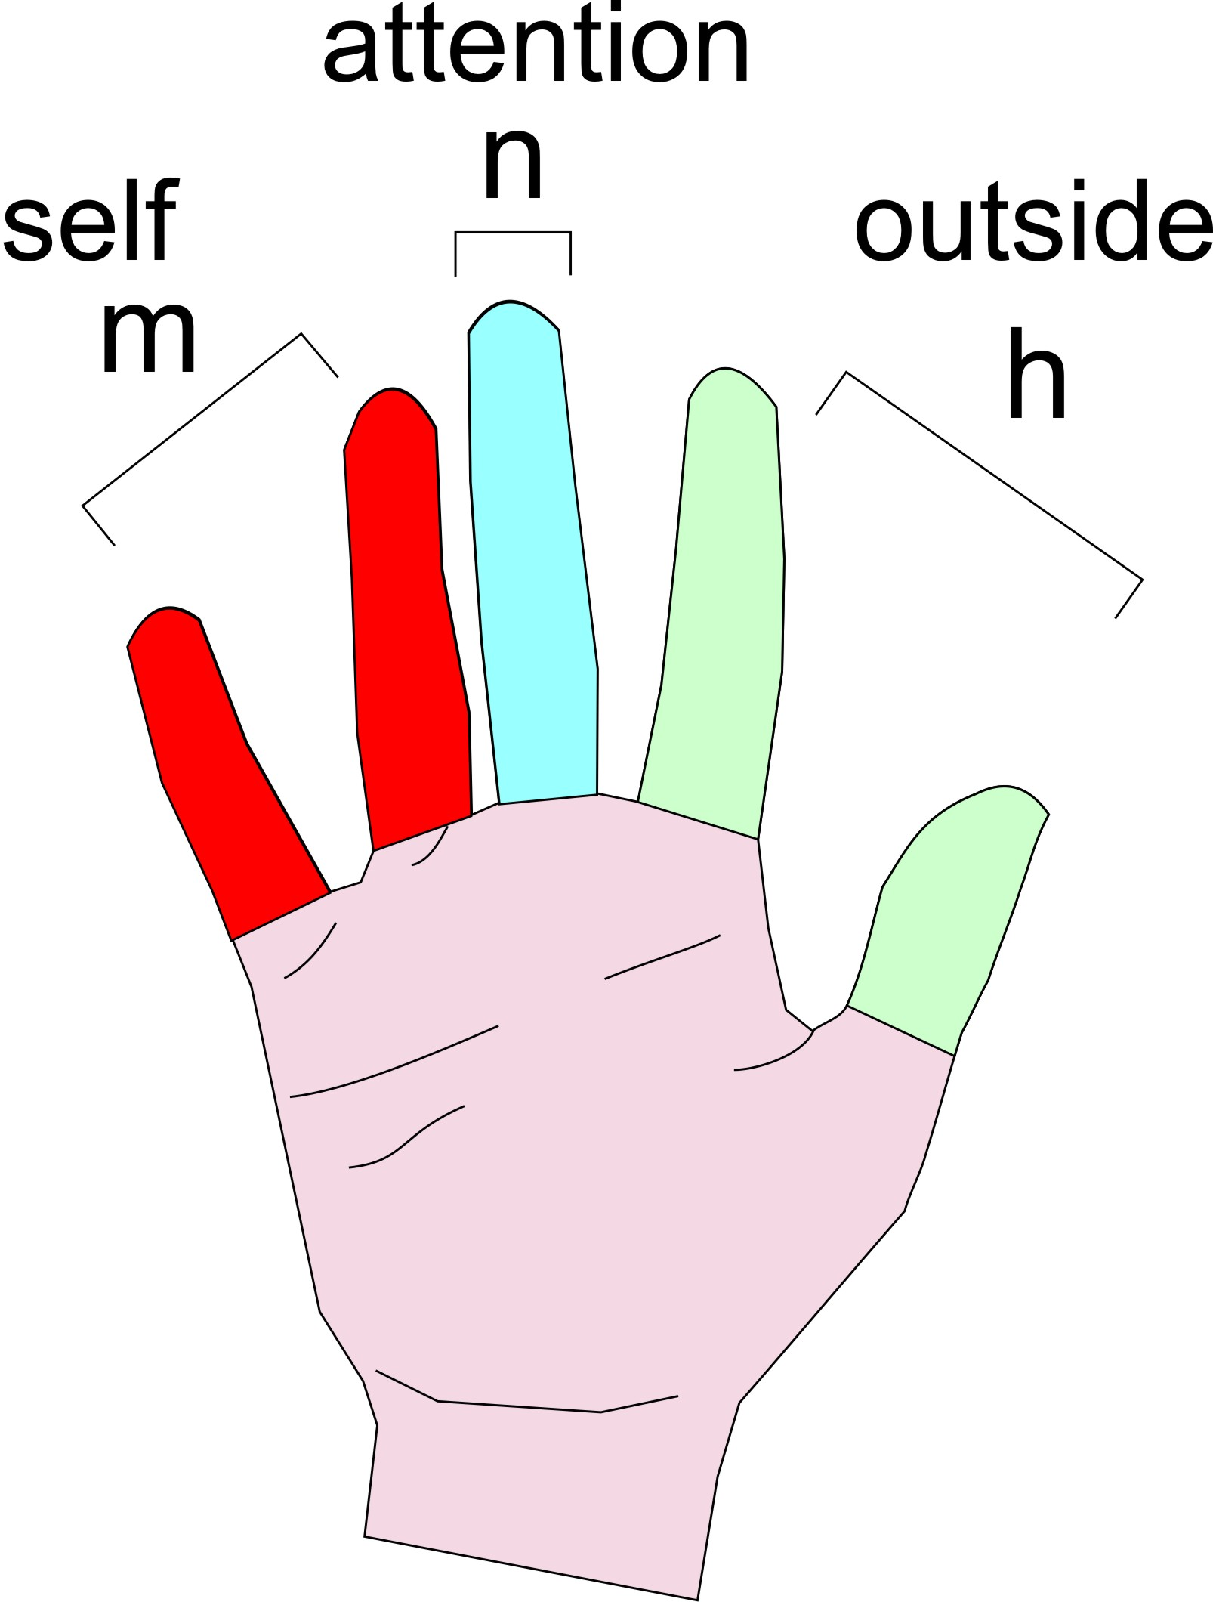
Observation 1: each of the sounds /h/, /n/, and /m/ activates particular fingers, respectively,
thumb-plus-index, the middle, and the fourth-plus-fifth fingers.

Action 2: When you place attention on the thumb-plus-index, the mind turns perceives the outer world. Focusing on the middle finger brings the mind to attention, and the fourth-plus-pinkie projects in it the “I” i.e.,the self.
(Still to check this:) You can work with either the entire finger or with its sections (phalanges). A phalange is divided the same way as the finger; in the pinkie the base of each section projects the self, while the mid point of the middle finger projects attention. However, there are also many combinations, e.g., attention and outer world appear together if you target the mid and top points of any section, and so on.

Engage focus on either the entire finger or at the base of one of the three sections (phalanges) of the finger. Outside of these locations the

Head tilt
Tilting the head left switches the mind to verbal mode, and tilting it right brings on the visual mode. You can note that when you are writing the head is slightly tilted left and backward, and when drawing the head slants right and forward.

Mantra reversed MB OUT!

Differences in how words appear in minds according to speakers of different languages (cf. Language Rule), mantras are not necessarily perfect in their Sanskrit, Chinese or Japanese forms. The sounds “mu” or “om” are better for Westerners when reversed as “um” and “mo”. For some “om mani padma hum” is better backwards as “hum padma mani om”.

External ear muscles MB OUT

Dogs and other animals point their ears up...maybe drop

Yoga Pragman Yoga Pragma Yoga Pragmatica PragmanYoga Yoga Practica
Yoga Pragmana

